Professional Ethics - Legal vs. Ethical

Many people confuse ‘ethical’ with ‘legal’. **Legal** is the word used to define anything that concerns the law or its workings. It is applicable to all practices, languages, processes, procedures, cultures, and other relative concepts in a system of the law. On the other hand, **ethics** is the word used to define the traditional norms and morals of an individual.

Many of the existing laws have originated from ethics while ethics is rooted in morals and the perception of the rightness or wrongness of an act or conduct.

Professional Ethics For Employees

The basic ethics a responsible and reliable employee practices are that he stays productive and takes responsibility for his actions, and that includes being accountable for the good or bad consequences of his actions.

In addition to this, qualities like being punctual, staying focused, and having an inclusive approach to problem-solving and decision-making are very important.

A professional should learn to take pride in the output he produces, lead by example, and address issues rather than crying over spilt milk.

A word of caution on inviting excessive friendliness runs through the management as an unwritten code. Many accept that there is a line that separates professional bonding and personal attachment that should be respected and never crossed. That being said, there is still a strong emphasis on clear, precise communication with everyone in a company.

An employee is, at the very least, entitled to the following rights at his workplace −

* No discrimination at work, especially on the basis of gender, nationality, religion, medical condition, and political affiliation.
* Healthy work-life balance, which means no long hours at work. Employees can also report if their employer makes unnecessary delays in delegating work.
* Protection of job for people with disabilities and medical conditions.
* Complete protection against sexual harassment of any kind and immunity from being forced to exchange favors for benefits.
* Freedom to discuss the terms and conditions of the employment with other employees and negotiating wages to suit lifestyle as per changing times.
* Right to ask for safe working conditions and reservation to answering questions on age, religion, nationality, and medical condition.
* Demanding certain changes and modifications regarding the working conditions to accommodate situations that might crop up due to their prevailing medical conditions.
* Right to form or participate a union that aims to improve the wages, lifestyle, working environment, and emphasizes on employee rights at the workplaces.

Whistleblowers are those employees or ex-employees of a company who report their company’s misdoings and expose the wrongful and unethical actions of their employer(s). Depending on the kind of whistleblowing they do, whistleblowers are categorized into the following two types −

* **Internal whistleblowers** − Internal whistleblowers report the unethical actions or illegal procedures of an employee or a group of employees of their company to someone who is a supervisor or senior authority in that company.
* **External whistleblowers** − External whistleblowers report the misgivings of their companies to external agencies. Most of the external whistleblowers come from huge corporations where the top management itself passes on unethical and at times, illegal directions to follow.

There are times when whistleblowers are also employees working with various other corporations, both local and international. Due to this, many whistleblowers are also categorized based on the organizations they come from. Depending on that, there are two types of whistleblowers −

* **Federal whistleblowers** − Federal whistleblowers work with government bodies and report cases that are related to national policies, etc.
* **Corporate whistleblowers** − Corporate whistleblowers work with private corporate houses and leak acts of cheating and fudging records and accounts to higher authorities.

## Codes of Ethics

The engineers who are represented as professionals, and who belong to a professional society need to have some moral responsibilities. A code of conduct is important for engineers to remain committed to their world.

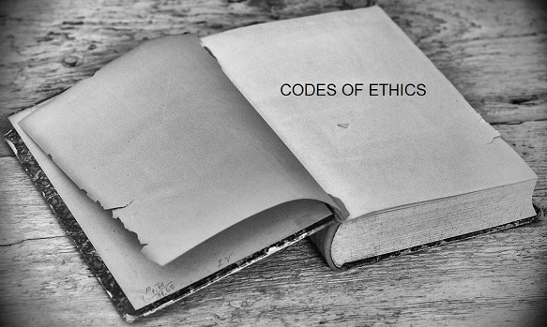

The engineering societies such as **AAES, ABET, NSPE, IEEE** and **AICTE** have framed these codes of ethics which are helpful to engineers to strengthen the moral issues on their work. The codes of ethics play at least eight important roles such as the following −

* **Serving and protecting the public** − Engineers are in a responsible position where trust and trustworthiness, both are essential. A code of ethics functions as a commitment by the profession as a whole that engineers will serve the public health, safety and welfare.
* **Guidance** − Codes are written in brief yet prove effective in offering general guidance to the engineers. More specific directions may be given in supplementary statements or guidelines, which tell how to apply the code. If needed, the assistance is obtained for further specification.
* **Inspiration** − Codes of ethics, which specify a collective commitment towards a profession, help in motivating the engineers towards ethical conduct. Actually, these codes make one feel really responsible and proud to be a professional thus motivating towards the commitment one should have towards one’s profession.
* **Shared Standards** − The standards established should be applicable to all individuals, in their particular professions. With the codes of ethics, the public is assured of engineers with minimum standard of excellence and the professionals are provided a fair way to compete.
* **Support for Responsible Professionals** − The professionals who act ethically have more positive support through these codes. A professional engineer who has the intention to stand by the codes of ethics, can have no harm from immoral professional obligations, as he can reject smoothly yet formally. As well, these codes can provide legal support for engineers criticized for living up to work-related professional obligations.
* **Education and Mutual understanding** − The codes which are widely circulated and officially approved by professional societies, promote a shared understanding among professionals, the public and government organizations about the moral responsibilities of engineers. These codes prompt discussion and reflection on moral issues.
* **Deterrence and Discipline** − The professionals who fail to follow the codes exhibit unethical conduct, which is evident from the disobedience towards their profession. Such an investigation generally requires paralegal proceedings designed to get at the truth about a given charge without violating the personal rights of those being investigated. This might lead to expulsion of those whose professional conduct has been proven unethical, which also leads to loss of respect from colleagues and the local community.
* **Contributing to the Profession’s Image** − Codes project the engineers as the professionals of ethically committed profession, which inspires them to work with great commitment and more effectively to serve the public. It can also win greater powers of self-regulation for the profession itself, while lessening the demand for more government regulation.

## Advantages of Codes of Ethics

Let us now see the following advantages of codes of ethics. The codes

* Set out the ideals and responsibilities of the profession.
* Exert a **de facto** regulatory effect protecting both clients and professionals.
* Improve the profile of the profession.
* Motivate and inspire practitioners, by attempting to define their raison d’etre.
* Provide guidance on acceptable conduct.
* Raise awareness and consciousness of issues.
* Improve quality and consistency.